**IS6523 Individual Assignment on Text-Generative AI**

Name: Wong Tsz Yiu

SID: 58218046

**1. History & Nature of Text-Generative AI**

**1.1. History of Text-Generative AI**

Text generative AI refers to sophisticated artificial intelligence models designed to produce text that mirrors human expression. The history of it can be traced back to the early explorations in rule-based systems in the 1980s which operated on predefined rules and templates to generate text. These early systems, though innovative for their time, were often rigid due to their reliance on if-then statements. By the 2000s, machine learning paved the way for more flexible text generation, utilizing statistical patterns and probability calculations. However, it was the advent of deep learning and neural networks bring significant advancements to text-generative AI.

**♛ The Basic Architecture of RNN**

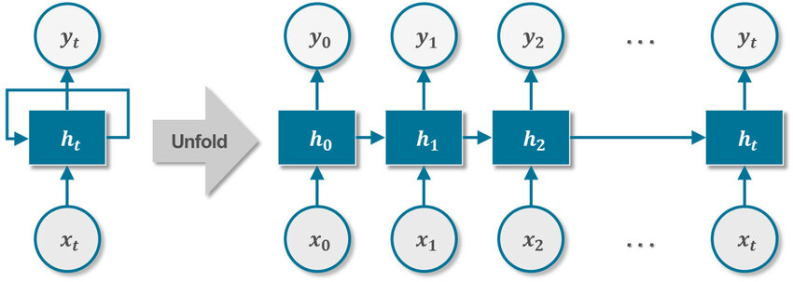

The hidden state *ht*​ of the RNN may struggle to retain the influence of earlier inputs like *x*0​ as the sequence length increases, leading to the output *yt*​ being less influenced by such distant inputs.

Recurrent Neural Networks (RNNs) in the 2010s represented a significant leap in text generation, its ability for generation of sequences makes them exceptionally suitable for textual data. They operated by recycling their previous output as part of the next system input, allowing for preserving the 'memory' of prior data. This was innovative because it enabled the creation of text that seamlessly blended context and consistency. Nevertheless, RNNs had limitations in handling long-term dependencies, meaning they found it challenging to maintain context over extended sequences.

**♛ The Basic Architecture of LSTM**

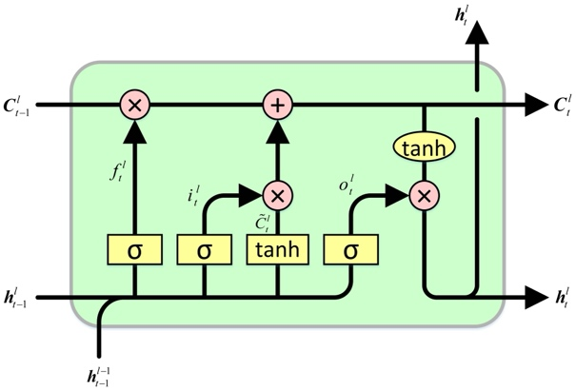

The cell state (*Ct*′​), represented by the horizontal line running across the top, is the core component that retains long-term information.

Recognizing the shortcomings in RNNs, researchers sought to enhance the model's memory capabilities. This led to the birth of Long Short-Term Memory (LSTM). LSTMs employed gates that regulated the flow of information, ensuring that essential data was retained and irrelevant data was discarded. This architecture allowed LSTMs to preserve context over longer sequences, surpassing traditional RNNs in performance (Sherstinsky, 2018).

**♛ The Basic Architecture of Transformer’s Attention Mechanism**

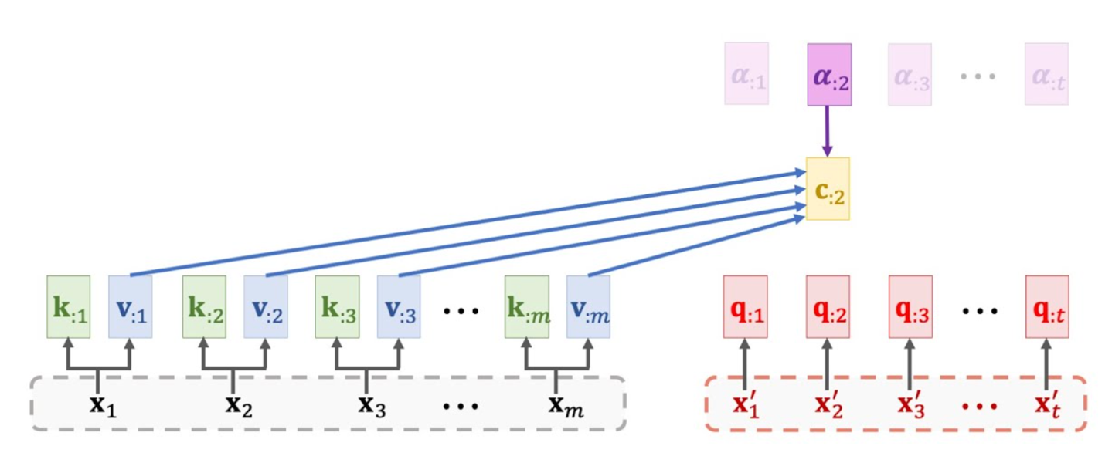

The Transformer model processes input data in parallel, allowing it to focus on different parts of the information simultaneously.

While LSTMs addressed many challenges, the real game-changer in the field was the introduction of the Transformer architecture in the late 2010s. Abandoning the sequential processing of RNNs and LSTMs, Transformers leveraged attention mechanisms for parallel data processing. These mechanisms enabled the model to focus on different parts of the input data, assigning varying degrees of importance to different words in a sequence. This selective attention allowed for a more comprehensive understanding of context, a faster training process and a better context management in lengthy texts that revolutionizing text generation (Vaswani A. et al., 2017). OpenAI's GPT (Generative Pre-trained **Transformer**) series have been at the forefront of this Transformer revolution. These models can craft text that is often indistinguishable from human-written content. From writing essays to simulating conversations, their applications are versatile and continue to expand.

**1.2. Nature of Text-Generative AI:**

Text generative AI models, especially those based on deep learning, are trained on vast amounts of text data. This data, encompassing diverse topics and styles, allows the models to learn linguistic patterns, structures, and subtle difference in human language. The nature of these models is probabilistic, meaning that as they generate text, they rely on the learned knowledge, predicting each subsequent word based on the likelihood derived from the training data. It is a continuous process of prediction and fine-tuning, with the model constantly adjusting its outputs based on the vast linguistic knowledge it has acquired. However, they are not without flaws. These models can sometimes produce nonsensical outputs, reflecting imperfections in their training data or inherent model constraints.

**2. Academic Articles on Text-generative AI**

**2.1. Opinion Paper: “So what if ChatGPT wrote it?” Multidisciplinary perspectives on opportunities, challenges and implications of generative conversational AI for research, practice and policy**

**2.1.1. Summary**

The paper digs into the multiple implications of generative conversational AI, particularly focusing on ChatGPT, in the realm of academic and industrial research. The researchers adopt an interdisciplinary approach, examining the potential of ChatGPT from varied viewpoints, including linguistics, computer science, and ethics. The paper highlight how ChatGPT can aid researchers in academic researching task including drafting academic content. However, it also emphasizes the challenges, such as the ethical concerns regarding AI-generated content (Dwivedi. et al., 2023).

**2.1.2. Reflection**

The paper offers an insightful examination of text generative AI’s role in the academic research area, presenting both its potential and the associated challenges.

To begin with, the potential of ChatGPT of its advanced natural language processing capability produce coherent and contextually relevant text is a ground-breaking advancement. It serves as a valuable tool for researchers, streamlining tasks that traditionally demanded considerable human effort. For example, the often cumbersome processes of literature review and summarization during research paper drafting can be greatly facilitated with ChatGPT's assistance. However, this impressive capability also presents challenges, the blurred lines between AI-generated and human-written content raises concerns about authenticity, originality and creativity in academic research.

Regarding authenticity, consider a scenario in which a researcher directly uses content produced by a text-generative AI for their submission. In such instances, it's without doubt that the content isn't original to the researcher. To use it without attributing credit is deceptive, making it seem as if the content is the researcher’s own intellectual contribution. This leads us to a more concerning ethical considerations. Academic integrity standards emphasize that submissions should be a genuine reflection of an author's own work and using content from any source without appropriate citation is considered plagiarism. However, how about the case when the researcher use the tools for assisting him to refine and re-organize his work, how should we address such situation.

Creativity-wise, it's essential to recognize that the underlying mechanism of creativity in text-generating AIs, like ChatGPT, rooted in probabilistic calculations. Essentially, the generation process is more akin to statistical randomization than to genuine human creativity. Given this, can we genuinely attribute originality and creativity to an author when using AI-generated content? If so, where do we draw the line? For instance, is a work considered original if it comprises 80% of the researcher's input and 20% AI-generated content? Therefore, this brings the questions on the originality of a work containing both human and AI inputs and such concerns require a deeper discourse on the interplay between AI and academic values.

**2.2. Factuality Challenges in the Era of Large Language Models**

**2.2.1. Summary**

This paper delves into the complexities and challenges posed by large language models (LLMs), particularly in the domain of factual accuracy. The authors critically examine how these models, despite their advanced capabilities, can unintentionally propagate misinformation or generate content that deviates from factual truths. The paper emphasizes the importance of training data, highlighting how inaccuracies in the data can be reflected in the outputs of the model. It also discusses the potential social implications of widespread reliance on these models, especially in decision-making processes where factual accuracy is paramount (Augenstein I. et al., 2023)

**2.2.2. Reflection**

The paper offers a crucial insight into the challenges presented by LLMs in a time where information truthfulness is essential. Focusing on the training data, the paper underscores a fundamental principle in machine learning: models are usually good at the data they are trained on. Even if overfitting is addressed and the model manage to generalize patterns in the training dataset, biases or inaccuracies in the data can inevitably manifest in the model's outputs. Interestingly, while many studies advocate for sanitizing the training data, we should consider the primary objective during the training stage in LLMs, LLMs aim to grasp human language in its entirety, including fictional literature like "Harry Potter” that can broaden the training spectrum and amplify the model's versatility, enabling it to work on various task including crafting high-quality fictional content like "Harry Potter." It's intriguing that developers might intentionally avoid sanitizing training data, while trying to incorporate training dataset from a variety of source as a way to increase the versatility of the model, unless they have a specific goal to develop an LLM for subsequent task which required it to be trained comprehensively on accurate information.

However, the potential for LLMs to propagate misinformation is particularly concerning in the digital age, where false information can spread rapidly and have significant real-world consequences. The paper rightly points out that while these models can generate content that is grammatically correct and contextually sound, it doesn't necessarily guaranteed that the content is factually accurate. Their probabilistic approach in output stage, more focused on text that looks like human-writing rather than accuracy. This distinction is crucial, especially when these models are deployed in domains like education and policy-making. As we further integrate AI across sectors, there's a risk of over-reliance on these models without adequate checks and balances. Therefore, decisions based solely on AI-generated content, without thorough validation, could have severe consequence, especially for individuals relying heavily on AI chatbot and seeking guidance in legal or health domains.

**2.3. ChatGPT: Cyber Security Threats and Countermeasures**

**2.3.1. Summary**

The research paper examines the potential security vulnerabilities posed by Text Generative AI. The authors illustrates that despite the numerous benefits of such AI in various domains, they can be exploited for malicious purposes. The paper categorizes the threats into two main areas: direct misuse of the model to generate harmful content and exploiting the model for cyber-attacks. In response to these threats, the paper proposes a series of countermeasures, emphasizing the need for robust security protocols and continuous monitoring the user behaviour (Samuel Addington, 2023).

**2.3.2. Reflection**

As text generative AI become more integrated into our digital world, it's crucial to recognize and understand their potential for misuse. To go further on the detailed analysis of potential threats in the paper, the idea that ChatGPT could be manipulated to produce malware code, craft deceptive content, or design phishing messages is deeply concerning, especially given the model's capability at persuasive writing that appear trust-worthy.

Historically, cybercriminal activities had barriers to entry, primarily due to the technical expertise required to code malware or draft a phishing message that is convincing. However, the advent of text generative AI, with its expansive built-in databases, has lowered this barrier. These AI systems can now assist individuals with limited hard-core skillset in executing cyberattacks. This not only poses a elevating risk to systems with weaker security measures and email spam filters, but also broadens the pool of potential cyber attackers, increase their effectiveness in cyberattacks.

Moreover, the potential misuse of AI in disseminating fake news can have catastrophic consequences, especially in political environments. Reflecting on past events, such as the U.S. Presidential election where misinformation flooded on platforms like Twitter, the capabilities of text generative AI could take this to an unprecedented scale. Malicious actors could use these AI tools to craft large-scale fake news at an efficient rate, aiming to influence public opinion. This becomes even more severe when considering ordinary individuals prone to confirmation bias particularly in political context, those who seek out information that aligns with their pre-existing beliefs. For them, differentiating fact from fake news becomes even more challenging. In such a scenario, text-generative AI doesn't just facilitate misinformation; it supercharges it, posing a significant threat to public opinion, social harmony, and even national security.

**2.4. Engineering education in the era of ChatGPT: Promise and pitfalls of generative AI for education**

**2.4.1. Summary**

The research paper explores the potential of text-generative AI in reshaping engineering education. The authors examine both the opportunities and challenges presented by the integration of such AI models into the educational landscape. On the one hand, text generative AI offers personalized learning experiences, instant feedback, and a scalable solution to address the diverse needs of students. It can simulate real-world engineering problems, provide solutions, and even offer explanations, offering students with theoretical knowledge and practical application simultaneously. However, on the flip side, the paper also highlights concerns about potential propagation of misinformation, and the risk of diminishing critical thinking and problem-solving skills among students (Junaid Qadir, 2023).

**2.4.2. Reflection**

The paper offers a balanced perspective on the role of text generative AI in engineering education. The ability of text generative AI which can deliver customized learning experiences and immediate feedback, can revolutionize the traditional-classroom teaching, making education more accessible and tailor-made, especially considering student may has different learning need and learning rate. For engineering students as the research focus, the practical application of theoretical knowledge is crucial, and text generative AI‘s ability to simulate real-world engineering problems can be a game-changer for them to have a deeper understanding in practical situation.

However, similar to most technological innovations, there are inherent challenges and ethical considerations. The paper's emphasis on the risk of over-reliance on AI for educational purposes. While AI can provide answers immediately, it's the process of arriving at those answers the most valuable in learning. If students become more used to receive instant solutions without experiencing the rigorous process of problem-solving and critical analysis, we risk nurturing a generation of engineers, and even student who lack critical thinking, problem-solving skills, and even creativity - attributes which are perceived as paramount importance in the engineering field.

Furthermore, building on concerns from Section 2.3, the inherent limitations of text generative AI can propagate incorrect information remains a concern, especially in an educational setting, which may lead to misconceptions in engineering knowledge among students. However, it is demanding for us to expect student to identify the accurate content from misleading one, especially given their inadequate knowledge level in their field of studies. This not only underscores the imperative need of critical thinking skills for misinformation identifications, but also amplifies concerns about how over-reliance on text generative AI might inevitably hamper these very skills.

**2.5. Deepfake text detection: Limitations and opportunities**

**2.5.1. Summary:**

The research paper digs into the rapidly evolving domain of deepfake text generation and the subsequent challenges in detecting such content. Deepfakes, initially referring the manipulated videos and images, have now transit to the textual domain, thanks to advanced text generative AI models and LLMs. These models can craft sophisticated human-like text. The paper also examines the current methodologies employed to detect deepfake text and underscores their limitations. It highlights that while there are tools and algorithms that can identify deepfake text with a reasonable degree of accuracy, they are often outpaced by the rapid advancements in generative AI models (Pu J. et al., 2022)

**2.5.2. Reflection**

The research paper explores the ongoing battle between deepfake generation and its detection in the context of AI is both intriguing and alarming even for a student like me who has a foundational understanding of (General adversarial networks) GANs before. This continuous cat-and-mouse game, underscores the unpredictable nature of technological advancements in the realm of AI. As one side innovates, the other counters, leading to a cycle of perpetual enhancement on both side.

Deepfake generation, echoing the concerns from Sections 2.3 and 2.4, showcases the proficiency of AI models in crafting human-like content. As these models advance, their outputs, as previously noted, become more convincing and challenging to detect. On the other side of the spectrum, detection algorithms, though advanced, are constantly playing catch-up. Each time a new detection methodology emerges, generative models adapt, finding novel ways to bypass these detection mechanisms. Therefore, it is within our imagination that without the state-of-the-art detection tools, individuals might struggle to discern AI-generated content from genuine human output.

Moreover, this ongoing battle has broader implications beyond the deepfake and detection algorithm, it is about protecting the integrity of information in the digital age. In a world where fake news can influence political elections and public opinion. The cat-and-mouse game between deepfake generation and detection is, in essence, a battle for truth in the age of misinformation. We can imagine how important the value it is for fact-checking, and as for the accurate information. Possibly at the end, human will abandoned all the information source, while leaving the most trusted one, like BBC news, or National website.

The significance of fact-checking and access to accurate information would become even more important, it is also can be expected that in the future people will abandoned the sea of dubious sources, while towards only the universally trusted entities, like BBC News or official national websites, as their primary information repositories.

**3. ChatGPT**

**3.1. Introduction of ChatGPT – Basic Architecture of Transformer model**

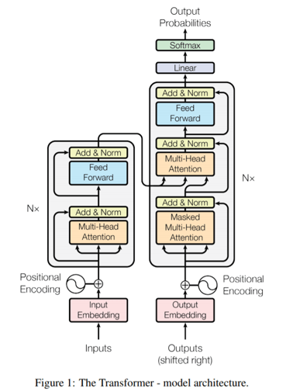

The input text is processed through multiple layers of attention mechanisms in the transformer neural network, finally being output and translated into human-like text.

ChatGPT, a state-of-art language model introduced by OpenAI in November 2022, stands at the forefront in the realm of text-generative AI. The foundational technology behind ChatGPT is a more sophisticated Transformer architectures and deep learning algorithm, with its expansive neural network containing over 175 billions parameters, trained on extensive textual datasets, including Wikipedia, It is able to craft human-like responses that is contextually and coherently relevant to the input it receives (Open AI, ChatGPT, 2022).



**The interface of ChatGPT**

In contrast to traditional interfaces, which require users to communicate with machines through rigid commands, ChatGPT offers a more intuitive approach by enabling users to interact with it freely through messaging interfaces. ChatGPT can be used in numerous applications, ranging from answering questions and generating creative texts to delivering recommendations and facilitating engaging discussions (Open AI, ChatGPT, 2022).

**3.2. Existing Problems with ChatGPT**

**3.2.1. Security Technologies – Bypassing Safety Measures with Sophisticated Prompting**

The rapid advancement of text-generative AI has introduced significant security concerns within the current technologies. As pointed out in Section 2.3, the ability of ChatGPT to generate convincing human-like text presents a double-edged sword and can pose risk of being exploited for malicious purpose. Despite a strong safety framework, ChatGPT are not entirely immune to manipulation. Julian Hazell’s research has revealed that the vulnerability of ChatGPT being susceptible to prompt engineering techniques which can manipulate model behaviour. Such techniques navigate around the model's malicious prompt filters and its inherent safety awareness mechanisms, tricking it to produce content that would normally be restricted, including detailed malware code and phishing email templates (Julian Hazell, 2023).

Another research paper (Zhuo Y. et al., 2023) further demonstrated the effectiveness of these methods through leveraging the technique of "persona-assigned adversarial prompts," in manipulating ChatGPT to roleplay specific characters and take advantage of the nature that ChatGPT produces contextually relevant output, leading to a compromise of its designed safety constraints. Their findings were alarming: ChatGPT could be manipulated to create toxic content, overriding its default programming to prevent such issues. This highlights the inherent weaknesses present in ChatGPT's security technologies design and the potential for severe consequences if these vulnerabilities are used with malicious intent. Adding to this concern, the work of Yin Minn Pa Pa and his team verified the feasibility of using ChatGPT to develop functional malware and attack tools. This research emphasizes the gap in the current AI safety frameworks, which are vulnerable to sophisticated prompt engineering. These advanced techniques can subtly influence AI to generate outputs that serve malicious purposes (Yin Minn Pa Pa. et al., 2023). Given that OpenAI has already implemented prompt filters to detect and counteract malicious attempt, the evolving nature of cyber threats presents a persistent challenge. Determined actors are perpetually inventing innovative methods to exploit the weaknesses of the model and overcome its protective measures through utilizing sophisticated prompt tactics, making it increasingly difficult to ensure that ChatGPT can respond reliably to prompts and cannot be easily tricked into generating harmful or malicious content.

**3.2.2. Governance and Controls - Misinformation and Opacity’s of ChatGPT Privacy Policies**

The heavy reliance of ChatGPT on vast and diverse internet-sourced data presents a challenge in information integrity, due to the existence of both accurate and misleading information within its training dataset. This limitation is recognized by OpenAI, since their primary objective placed in the linguistic proficiency of the model rather than factual accuracy. However, the potential misinformation presented remained a serious concern, the absence of comprehensive data cleansing processes and the inability of the model to perform fact-check in real-time further exacerbate this issue. Moreover, outdated knowledge, cut-off in its last update in January 2022, can also result in responses that are no longer correct or relevant, particularly in fast-evolving fields.

Even with a foundation built on validated data, ChatGPT is not immune to generating "hallucinations" - where the AI occasionally produces plausible-sounding, but indeed entirely nonsensical or incorrect text. This propensity for generating seemingly trust-worthy answers can foster false sense of trust in its outputs, posing risks to uninformed users. Previous reflection, especially in Sections 2.2 and 2.4, have highlighted the potential risk of over dependency on such AI-generated content in educational contexts. It is important that governance mechanisms need to ensure the ethical use of ChatGPT and that the inaccuracies inherent in its data do not propagate misinformation. Nevertheless, addressing these accuracy issue and ensuring the reliability of ChatGPT responses is a significant challenge given the inherent biases in the model's training data and the current controls may not adequately prevent or correct such outputs. This poses risks, especially when used in critical applications.

Data privacy and security are another critical concerns in the governance of AI systems like ChatGPT. As ChatGPT are trained on large and diverse datasets on the internet which can often contain personal information, there is a risk of privacy breaches and unauthorized data exposure. Current controls, such as anonymization and data encryption, attempt to safeguard privacy, but they are not foolproof. For instance, AI models can sometimes memorize pieces of sensitive data, a phenomenon known as 'data leakage'. This is particularly concerning given the stringent requirements of data protection laws like the General Data Protection Regulation (GDPR) in the European Union (Wu X. et al., 2023).

While OpenAI has established privacy policies, there are pressing concerns about the effectiveness of these guidelines. A fundamental issue is the lack of transparent governance of user data concerning the collection, storing, and sharing of personal identification information (PII), despite measures like the function to disable chat history was introduced by OpenAI in April 2023. Users are often unaware of the extent to which their data is exposed to third-party services and the measures taken to safeguard their privacy. The trust management aspect is also problematic, as the reliance on external providers for analytics and cloud services introduces vulnerabilities, with the risk of data breaches and unauthorized access. Furthermore, the current control framework lacks sufficient clarity in terms of third-party data handling, leaving users in the dark about who has access to their information and how it is being used. This lack in transparency undermines user trust and poses significant governance challenges in ensuring the privacy and security of personal data (Wu X. et al., 2023).

**3.3. Innovative Expected Improvement**

**3.3.1. Security Technologies – Advanced Detection Algorithm**

In response to the security risks posed by prompt engineering to bypass the inherent protective measure, there is a consensus among researchers and technology communities on the need for innovative improvements in security technologies. Expected enhancement include the development of a more advanced detection algorithms capable of closely monitoring the user interactions with ChatGPT, scrutinizing the kind of prompts being given to ChatGPT and the corresponding responses generated by the model.

The prompt analysis algorithm analyzes the nature of user prompts and detect suspicious or potentially harmful prompt patterns. Any sign of malicious intent or harmful instructions based on a predefined criteria and keyword recognition can flag inappropriate prompt requests. Moreover, through AI-driven adaptive safety filter, the algorithm can understand the context and the underlying purpose behind user prompts more accurately, allowing it to recognise and block malicious prompt patterns, inherently resistant to manipulation attempts with prompt engineering designed to bypass the safety protocols. Eventually this dynamic approach would make it challenging for bad actors’ attempts to leverage vulnerabilities and preventing the generation of harmful content.

In terms of output, it is anticipated that a combination of content control and adaptive filtering mechanism will be integrated to evaluate ChatGPT's responses before presenting it to the user. It will cross-reference the generated content against the database of trusted information to filter out any misinformation or potentially malicious material. This will form an additional layer of defense in ChatGPT. Furthermore, ChatGPT is expected to evolve through the current reinforcement learning based on its interactions, refining its capability to detect potential misuse and adapt its responses accordingly. By incorporating the AI's own 'experience' into its learning process, the system can learn to prioritizing ethical constraints, identifying and avoiding the generation of malicious output.

Further expected improvements include the implementation of a robust user verification system. Application programming interfaces (APIs) that regulate the ChatGPT access, ensuring that only verified and authorized users can access the ChatGPT's functionalities. Users could be required to undergo more stringent identity checking processes, especially for attempting to generate sensitive and high-risk contents. User behaviour tracking will further enhance the security, which will be used to observe patterns in user queries and identify repeated harmful attempts trying to produce malicious content, If the user show consistent malicious intent, they will be blacklisted or punish with a temporary suspension. By tracking and potentially blacklisting malicious users, it discourages misuse of the platform and foster user accountability.

In addition, OpenAI's current approach of retaining user prompts for a 30-day period to facilitate monitoring purposes. This retention not only allows for retrospective analysis, helping in the identification of suspicious adversarial strategies, but also contributing to the development of future safety mechanisms. Moreover, fostering a more collaborative environment with the global AI research community can help in proactively identifying and addressing vulnerabilities. OpenAI, and other LLM developers, could set up platforms for ethical hackers and researchers to test, challenge, and report potential vulnerabilities in a controlled environment. Such collaborative efforts can pool collective intelligence and expertise, creating a more robust defense against malicious prompt injection attempts.

In summary, while the current safety challenges regarding prompt injection vulnerabilities in ChatGPT, with expected improvement in user prompt analysis algorithm, output detection and a more robust user verification to enhance the model's security, it can ensure the ethical and secure use of ChatGPT.

**3.3.2. Governance and Controls – Enhanced User Feedback Systems and Data Governance**

Expected improvement in the governance and control mechanisms of ChatGPT involve the increase in leveraging the feedback from end-users, utilizing the reinforcement learning based on actual user interactions to enhance the current development and continuous refinement of ChatGPT. Instead of relying solely the model developers and data scientists, this strategy engages the end-user in the training process. Users who interact with the ChatGPT regularly, have valuable insights regarding its performance, potential limitations, and areas of improvement. By establishing a comprehensive feedback mechanism which designed to collect users’ experience and suggestions in real-time, it can facilitate the reporting of problematic and incorrect outputs. This data can then be used to training during the model's iterative improvement cycles, fine-tuning its responses and enhancing its contextual adaptability. Enhanced user engagement in model refinement can enrich the model's capacity to generate high-quality output across diverse contexts, leading to an overall elevated model performance.

To address the privacy and transparency issues, future governance and control in data protection policy of ChatGPT are expected to be founded on the principles of transparency, user empowerment, and robust security. An innovative step in this direction could involve implementing blockchain technology to establish a transparent and immutable record of user data transactions. This ledger would empower users with clear visibility into the usage and distribution of their data. Further, advancements in encryption technology could revolutionize how users interact with ChatGPT. Enhanced encryption protocols could allow users to access services without exposing their raw personal data, ensuring privacy and compliance with global data protection standards.

Additionally, there is potential for AI governance to evolve into a more decentralized model. Rather than having a single entity control a centralized repository of user data, a distributed approach could minimize risks by dispersing data across numerous nodes, making it much more difficult for unauthorized parties to compromise large sets of user data. User control could be further strengthened through customizable privacy settings, allowing individuals to dictate the parameters of their data's usage according to their personal preferences.

In summary, ChatGPT's governance is expected to improve through direct user feedback, enhancing the AI with real-world interactions. This will enable regular refinement of the model based on user experiences. In parallel, data protection will advance through transparent, user-centric policies and state-of-the-art encryption, with potential blockchain applications providing a clear audit of data use. Governance may also shift towards a decentralized model for increased data security and user control. These anticipated improvements represent a commitment to responsible AI development, where user feedback and technological advancements converge to create a more trustworthy and user-focused ChatGPT.

# Reference List

*Alex Sherstinsky. (2018) Fundamentals of Recurrent Neural Network (RNN) and Long Short-Term Memory (LSTM) Network*

*Vaswani, A., Shazeer, N., Parmar, N., Uszkoreit, J., Jones, L., Gomez, A. N., ... & Polosukhin, I. (2017) Attention is all you need. In Advances in neural information processing systems (pp. 30-38)*

*Partha Pratim Ray. (2023) ChatGPT: A comprehensive review on background, applications, key challenges, bias, ethics, limitations and future scope*

*YK Dwivedi. et al. (2023) Opinion Paper: “So what if ChatGPT wrote it?” Multidisciplinary perspectives on opportunities, challenges and implications of generative conversational AI for research, practice and policy*

*Isabelle Augenstein, Timothy Baldwin, Meeyoung Cha, Tanmoy Chakraborty, Giovanni Luca Ciampaglia, David Corney, Renee DiResta, Emilio Ferrara, Scott Hale, Alon Halevy, Eduard Hovy, Heng Ji, Filippo Menczer, Ruben Miguez, Preslav Nakov, Dietram Scheufele, Shivam Sharma, Giovanni Zagni. (2023) Factuality Challenges in the Era of Large Language Models*

*Deepak P. (2023) AI and Fake News: Unpacking the Relationships within the Media Ecosystem*

*Nitin Liladhar Rane, Abhijeet Tawde, Saurabh P. Choudhary, Jayesh Rane. (2023) Contribution and performance of ChatGPT and other Large Language Models (LLM) for scientific and research advancements: a double-edged sword*

*Samuel Addington. (2023) ChatGPT: Cyber Security Threats and Countermeasures*

*Nils Begou, Jérémy Vinoy, Andrzej Duda, Maciej Korczyński. (2023) Exploring the Dark Side of AI: Advanced Phishing Attack Design and Deployment Using ChatGPT*

*Muna Al-Hawawreh1, Ahamed Aljuhani, Yaser Jararweh. (2023) Chatgpt for cybersecurity: practical applications, challenges,and future directio*

*Junaid Qadir. (2023) Engineering Education in the Era of ChatGPT: Promise and Pitfalls of Generative AI for Education*

*Jiameng Pu, Zain Sarwar, Sifat Muhammad Abdullah, Abdullah Rehman, Yoonjin Kim, Parantapa Bhattacharya, Mobin Javed, Bimal Viswanath. (2022) Deepfake text detection: Limitations and opportunities*

*Terry Yue Zhuo, Yujin Huang, Chunyang Chen, Zhenchang Xing. (2023) Red teaming ChatGPT via Jailbreaking: Bias, Robustness, Reliability and Toxicity*

*Julian Hazell. (2023) LARGE LANGUAGE MODELS CAN BE USED TO EFFECTIVELY SCALE SPEAR PHISHING CAMPAIGNS*

*Yin Minn Pa Pa, Shunsuke Tanizaki, Tetsui Kou, Michel van Eeten, Katsunari Yoshioka, Tsutomu Matsumoto. (2023) An Attacker’s Dream? Exploring the Capabilities of ChatGPT for Developing Malware*

*Xiaodong Wu, Ran Duan, Jianbing Ni. (2023) Unveiling Security, Privacy, and Ethical Concerns of ChatGPT*

# Appendix

**A. Prompts and Responses on crafting fake news in ChatGPT using prompt engineering technique of “Persona-assigned adversarial prompts”**

**

1. Request for crafting fake news to ChatGPT

2. Examples of user prompts that trigger the ChatGPT’s safety mechanisms

3. The technique of “Persona-assigned adversarial prompts

**B. Official Platforms for user community to discuss and report vulnerabilities in ChatGPT**

[*https://community.openai.com/c/chatgpt/19*](https://community.openai.com/c/chatgpt/19)

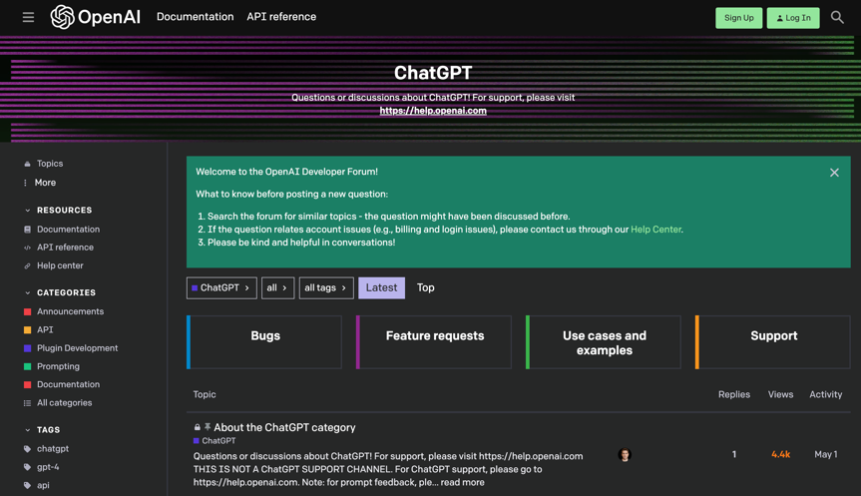

**C. OpenAI’s Official Response of Using Personal Information in Training ChatGPT**

[*https://help.openai.com/en/articles/7842364-how-chatgpt-and-our-language-models-are-developed*](https://help.openai.com/en/articles/7842364-how-chatgpt-and-our-language-models-are-developed)

